[1] CSA-1560 CLOUD COMPUTING LAB PRACTICAL

7.Create a simple cloud software application for Students Attendance System using any Cloud Service Provider to demonstrate SaaS include the necessary fields such as name of the students, course, present , Absent, course attendance, request, grade, attendance percentage, etc

STEP-1:

Login into zoho.com and create an account.Then go to zoho creator and create a new application starting with a new form.Add or insert the required fields.

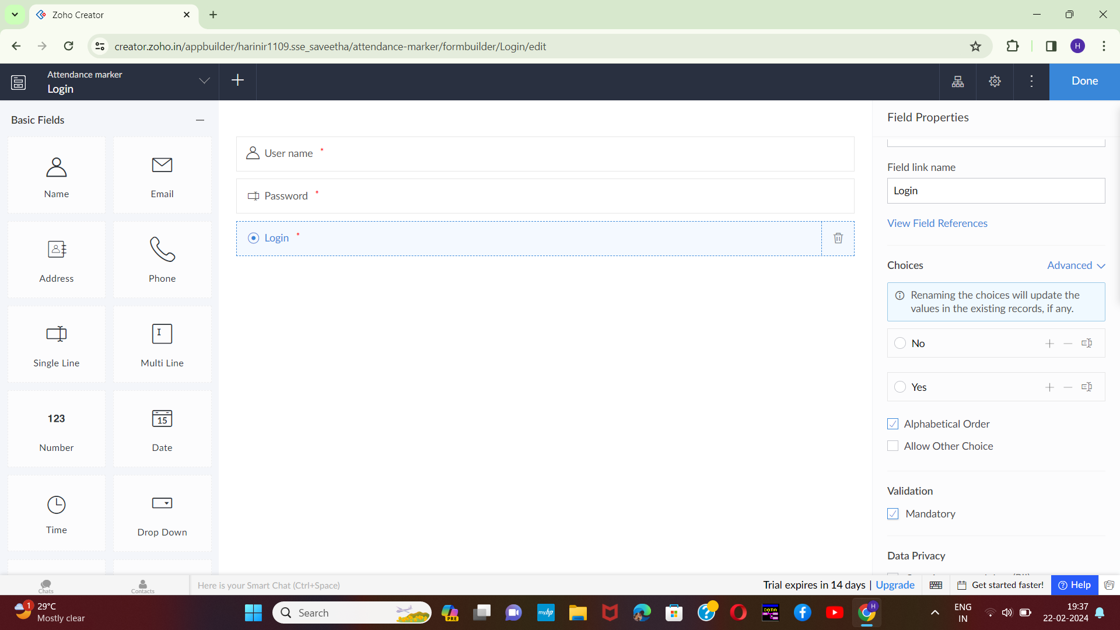

STEP-2:

Execute or run the model and get the required login form in live.

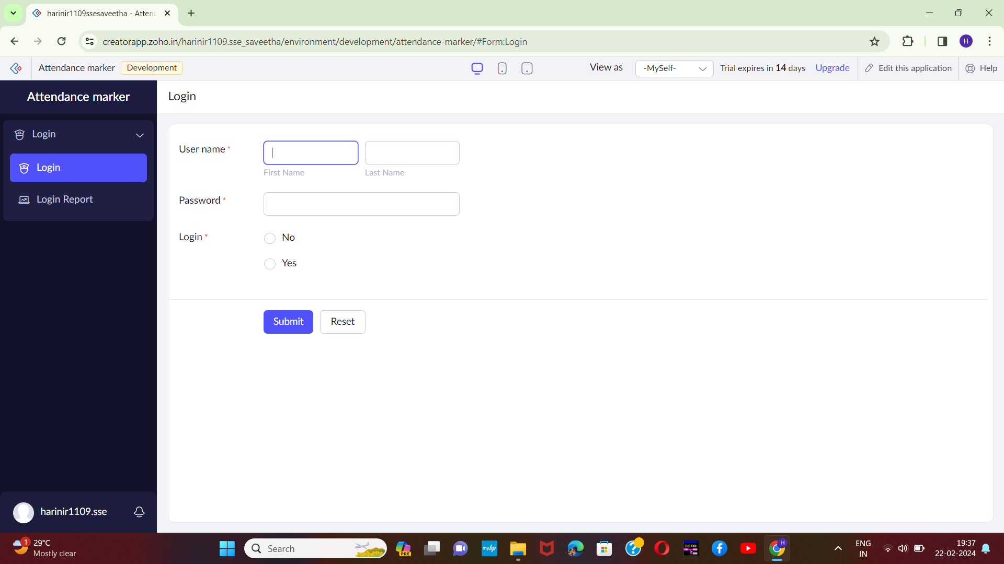[2]

STEP-3:

Next step is to add another form which consists of students' details with the fields.

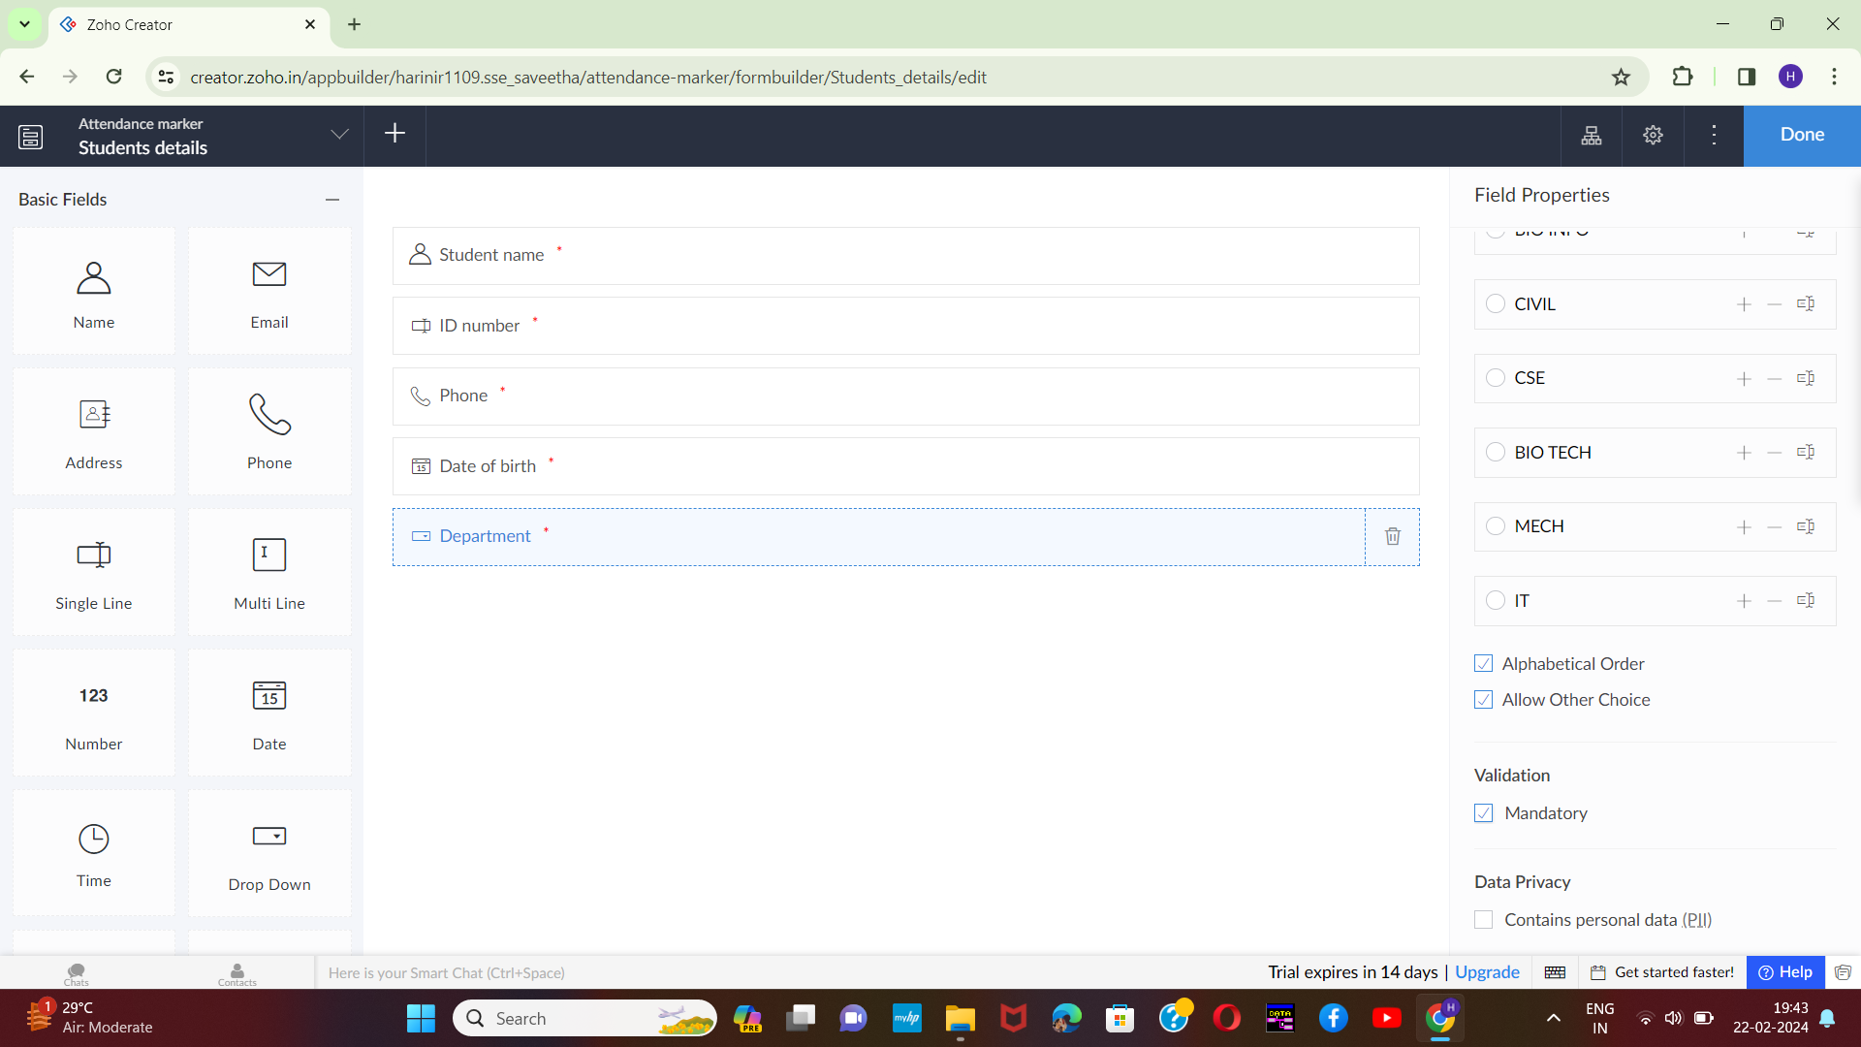

[3]STEP-4:

Execute or run the model and get the required students details from live.

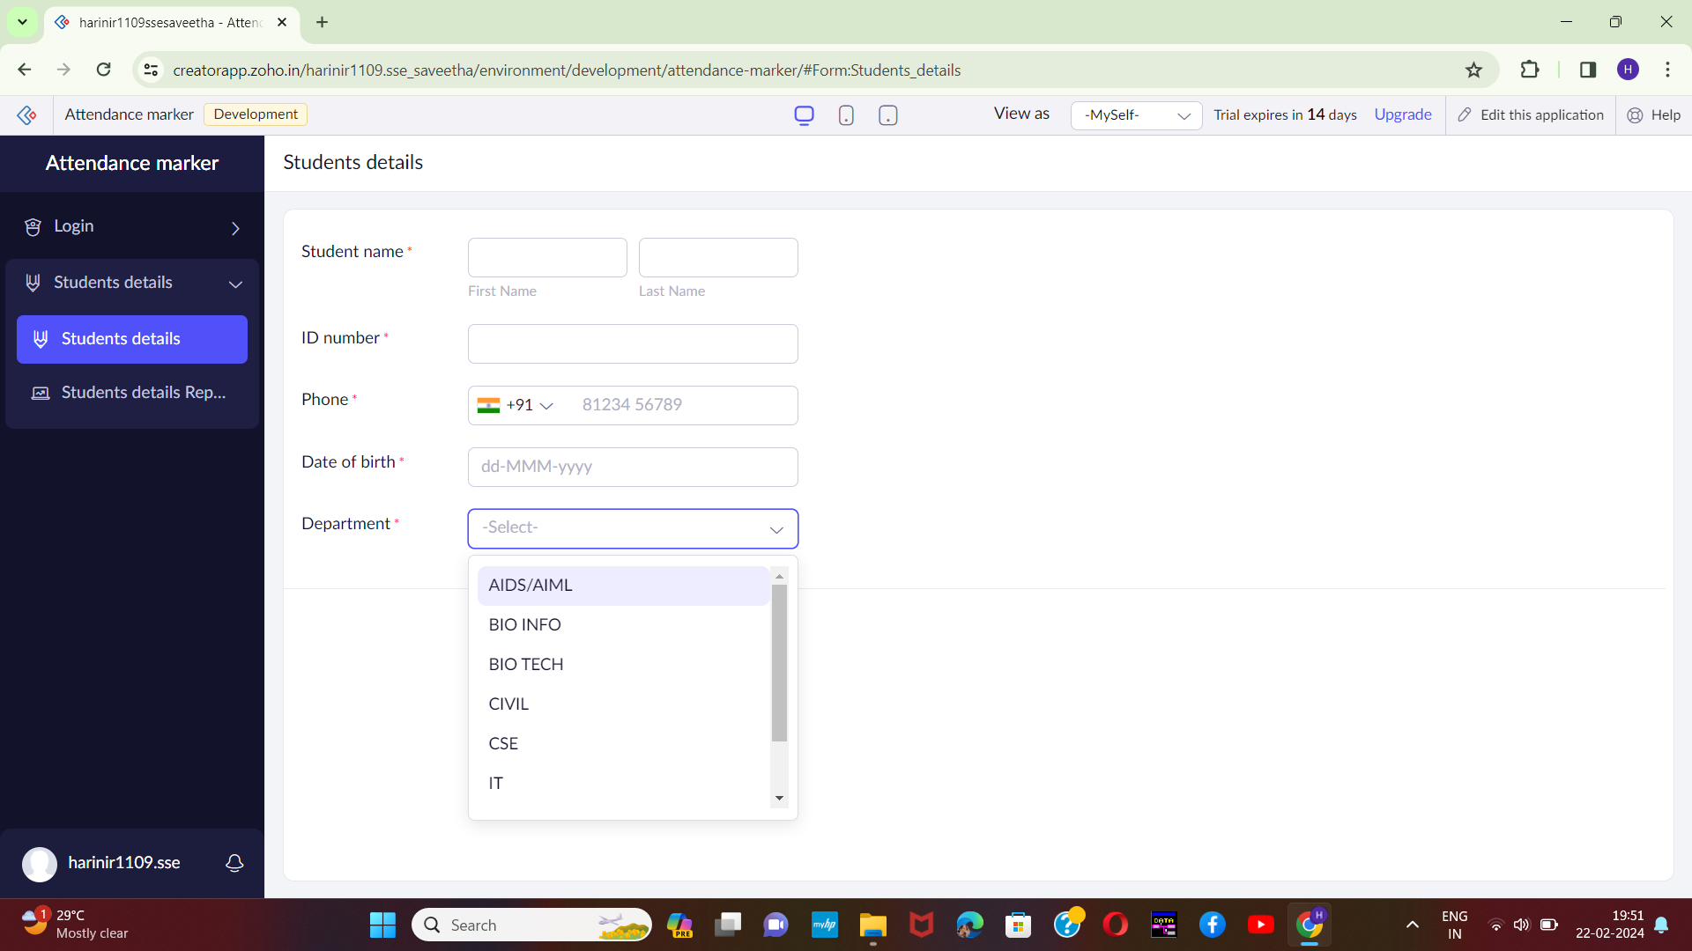

STEP-5:

Next step is to add another form which consists of course attendance details with the fields.

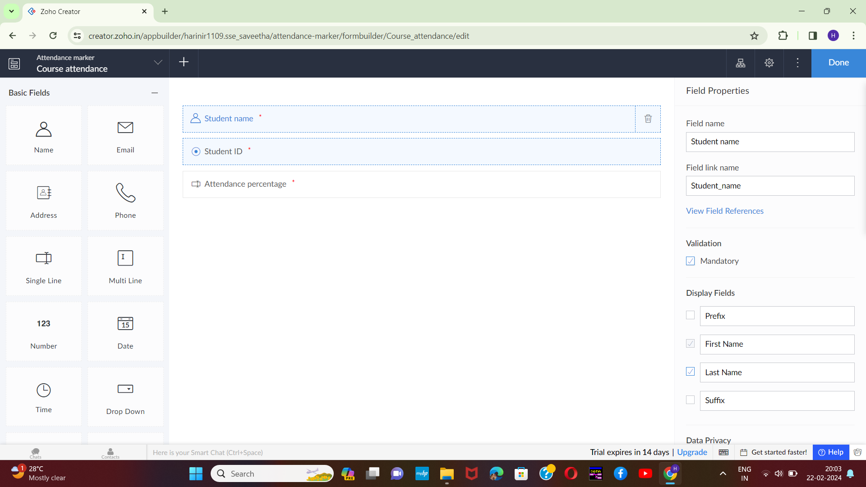[4]

STEP-6:

Execute or run the model and get the attendance details from live.

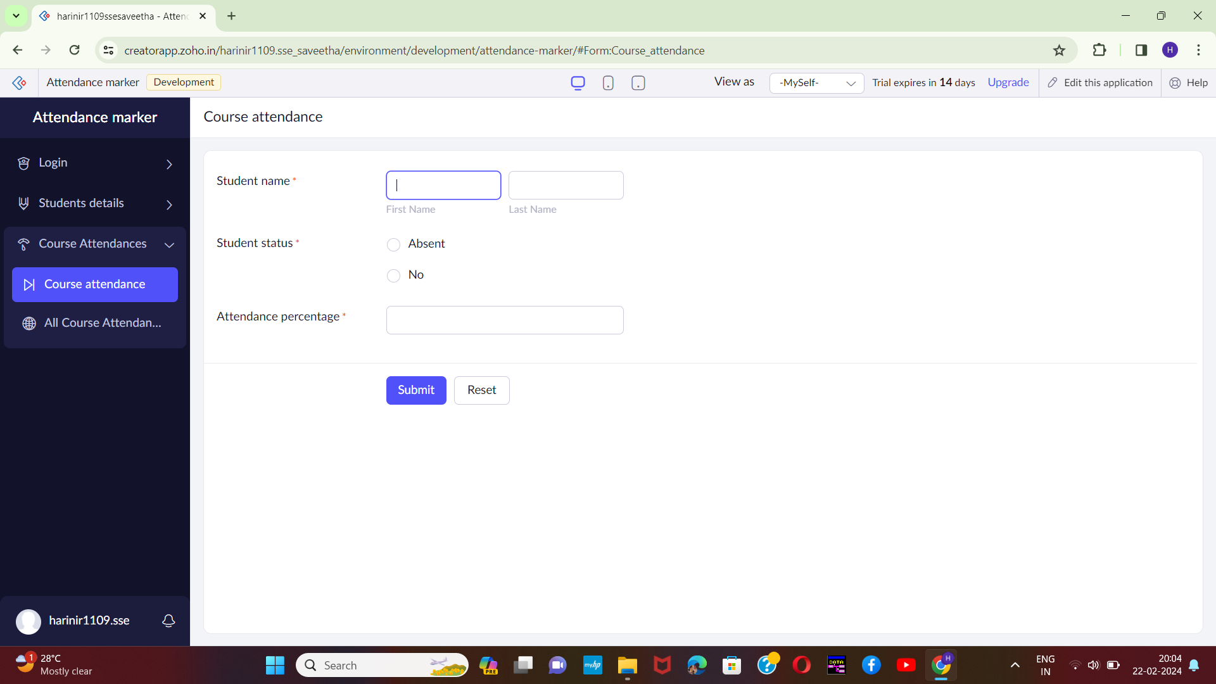

STEP-7:

Next step is to add another form which consists of logout details.

[5]

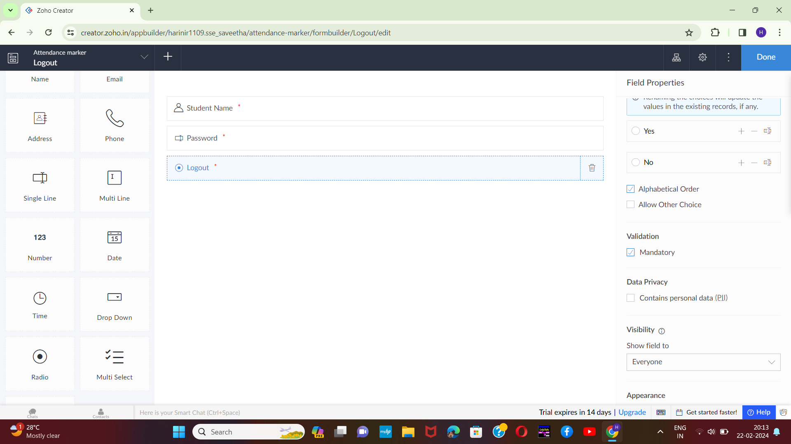

STEP-8:

The last step is to run and execute the logout details form and end the program.

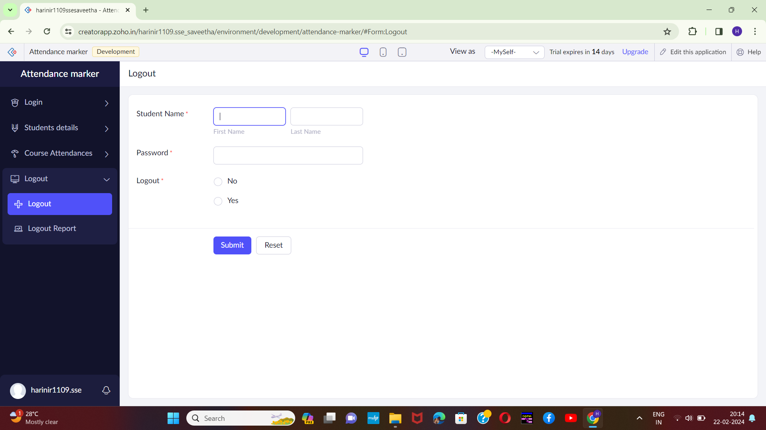

1.
2.
3.
4.
5.